Android Assignment 3

Name :- Atharva Mahamuni

Roll no :- 2002276

---------------------------------------------------------------------------------------------------------------------------

Q1. Create a java android application to demonstrate Alert Dialog Box. Create a button

on the screen. On clicking the button, the alert dialog should ask the question “Do you want to continue?”. ‘No’ button click should stop the application & ‘Yes’ button click should go to next activity.

MainActivity.java

package com.example.assignment3q1;

import androidx.appcompat.app.AlertDialog;

import androidx.appcompat.app.AppCompatActivity;

import android.content.DialogInterface;

//import android.support.v7.app.AppCompatActivity;

import android.os.Bundle;

import android.view.View;

import android.widget.Button;

import android.widget.Toast;

public class MainActivity extends AppCompatActivity {

Button closeButton;

AlertDialog.Builder builder;

@Override

protected void onCreate(Bundle savedInstanceState) {

super.onCreate(savedInstanceState);

setContentView(R.layout.activity_main);

closeButton = (Button) findViewById(R.id.button);

builder = new AlertDialog.Builder(this);

closeButton.setOnClickListener(new View.OnClickListener() {

@Override

public void onClick(View v)

builder.setMessage("Do you want to Continue ?")

.setCancelable(false)

.setPositiveButton("Yes", new DialogInterface.OnClickListener() {

public void onClick(DialogInterface dialog, int id) {

// next activity

dialog.cancel();

Toast.makeText(getApplicationContext(),"you choose yes action for alertbox",

Toast.LENGTH_SHORT).show();

}

})

.setNegativeButton("No", new DialogInterface.OnClickListener() {

public void onClick(DialogInterface dialog, int id) {

// Action for 'NO' Button

finish();

Toast.makeText(getApplicationContext(),"you choose no action for alertbox",

Toast.LENGTH_SHORT).show();

}

});

//Creating dialog box

AlertDialog alert = builder.create();

//Setting the title manually

alert.setTitle("AlertBox");

alert.show();

}

});

}

}

activity_main.xml

<?xml version="1.0" encoding="utf-8"?>

<androidx.constraintlayout.widget.ConstraintLayout xmlns:android="http://schemas.android.com/apk/res/android"

xmlns:app="http://schemas.android.com/apk/res-auto"

xmlns:tools="http://schemas.android.com/tools"

android:layout_width="match_parent"

android:layout_height="match_parent"

tools:context=".MainActivity">

<TextView

android:layout_width="wrap_content"

android:layout_height="wrap_content"

android:text="Hello World!"

app:layout_constraintBottom_toBottomOf="parent"

app:layout_constraintLeft_toLeftOf="parent"

app:layout_constraintRight_toRightOf="parent"

app:layout_constraintTop_toTopOf="parent" />

<Button

android:id="@+id/button"

android:layout_width="wrap_content"

android:layout_height="wrap_content"

android:text="Alert"

app:layout_constraintBottom_toBottomOf="parent"

app:layout_constraintLeft_toLeftOf="parent"

app:layout_constraintRight_toRightOf="parent"

app:layout_constraintTop_toTopOf="parent"/>

</androidx.constraintlayout.widget.ConstraintLayout>

Output :-

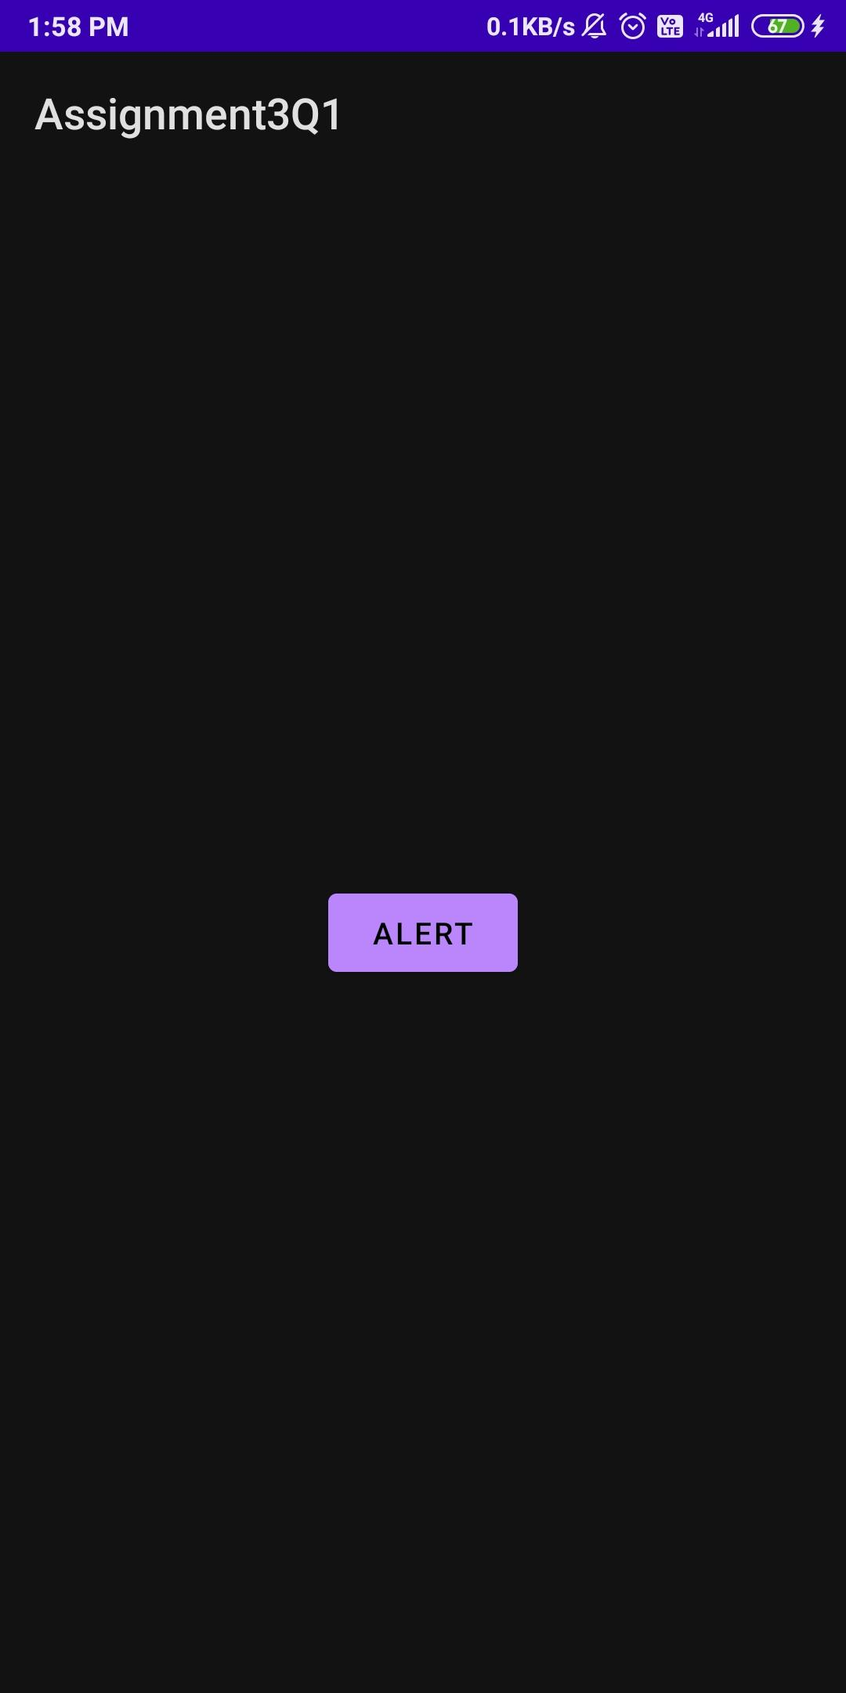

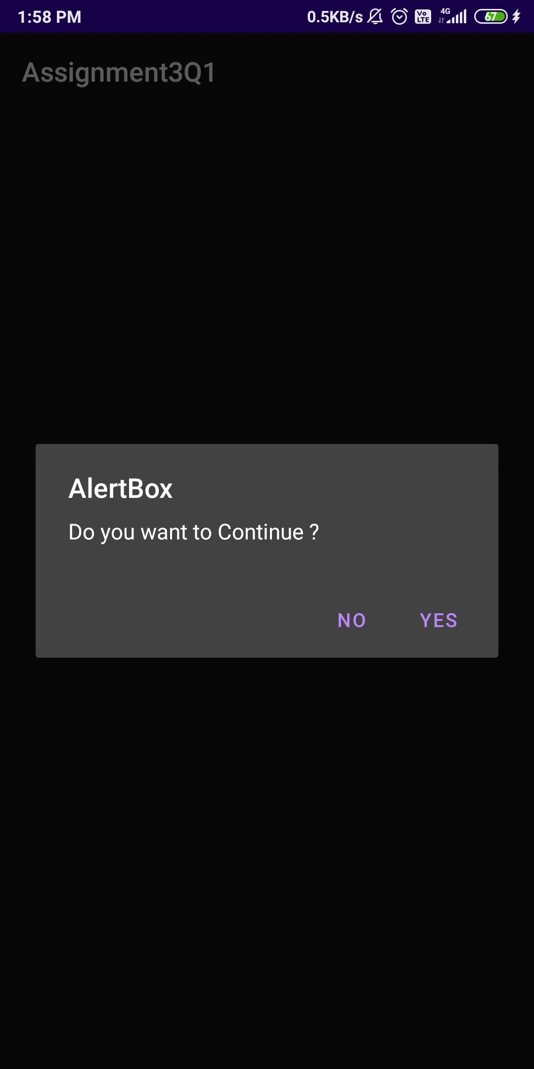

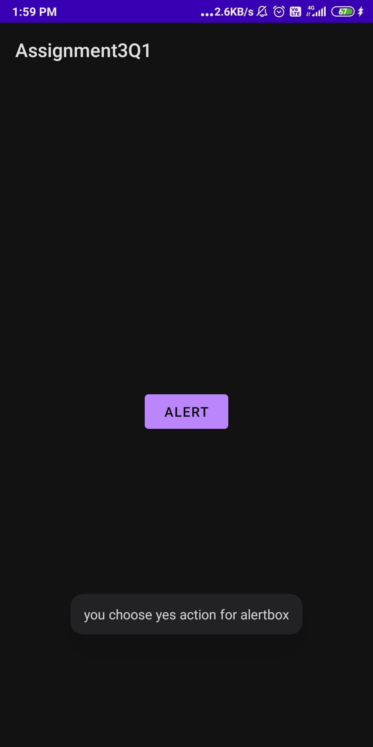

---------------------------------------------------------------------------------------------------------------------------

Q2. Create a java android application using Context Menu. Add any five mobile brand

names as menu items. Toast the selected menu item.

MainActivity.java

package com.example.assignment2q2;

import androidx.appcompat.app.AppCompatActivity;

import android.os.Bundle;

import android.view.ContextMenu;

import android.view.MenuItem;

import android.view.View;

import android.widget.Button;

import android.widget.Toast;

public class MainActivity extends AppCompatActivity {

@Override

protected void onCreate(Bundle savedInstanceState) {

super.onCreate(savedInstanceState);

setContentView(R.layout.activity_main);

Button btn = (Button) findViewById(R.id.btnShow);

registerForContextMenu(btn);

}

@Override

public void onCreateContextMenu(ContextMenu menu, View v, ContextMenu.ContextMenuInfo menuInfo) {

super.onCreateContextMenu(menu, v, menuInfo);

menu.setHeaderTitle("Context Menu");

menu.add(0, v.getId(), 0, "Apple");

menu.add(0, v.getId(), 0, "Google");

menu.add(0, v.getId(), 0, "Redmi");

menu.add(0, v.getId(), 0, "Samsung");

menu.add(0, v.getId(), 0, "Lenovo");

}

@Override

public boolean onContextItemSelected(MenuItem item) {

Toast.makeText(this, "Selected Item: " + item.getTitle(), Toast.LENGTH_SHORT).show();

return true;

}

}

activity_main.xml

<?xml version="1.0" encoding="utf-8"?>

<LinearLayout xmlns:android="http://schemas.android.com/apk/res/android"

android:layout_width="match_parent"

android:layout_height="match_parent"

android:orientation="vertical" >

<Button

android:id="@+id/btnShow"

android:layout_width="wrap_content"

android:layout_height="wrap_content"

android:text="Long press me"

android:layout_marginTop="200dp" android:layout_marginLeft="100dp"/>

</LinearLayout>

Output :-

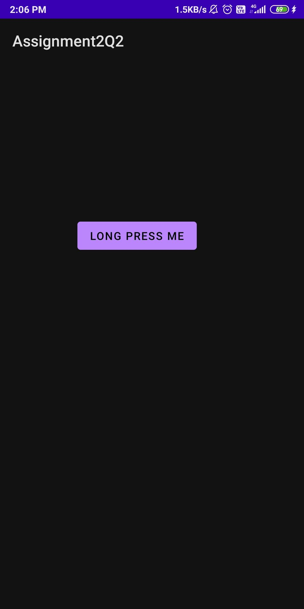

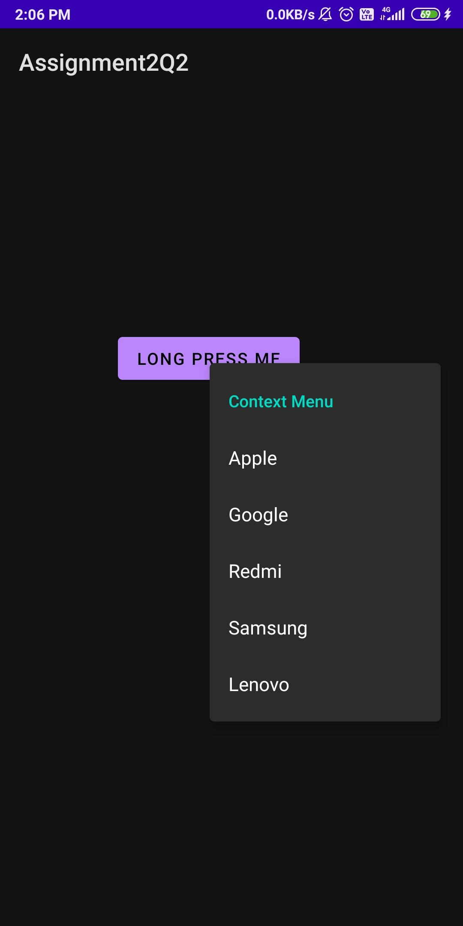

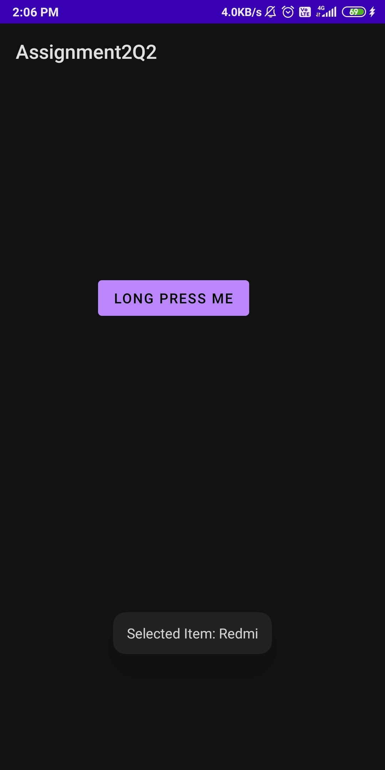

---------------------------------------------------------------------------------------------------------------------------

Q3 . Create a java android application that creates alarm clock.

activity_main.xml

<?xml version="1.0" encoding="utf-8"?>

<LinearLayout

xmlns:android="http://schemas.android.com/apk/res/android"

android:layout_width="match_parent"

android:layout_height="match_parent"

android:orientation="vertical">

<!--Added Time picker just to pick the alarm time-->

<!--gravity is aligned to center-->

<TimePicker

android:id="@+id/timePicker"

android:layout_width="wrap_content"

android:layout_height="wrap_content"

android:layout_gravity="center" />

<!--Added Toggle Button to set the alarm on or off-->

<!--ByDefault toggleButton is set to false-->

<ToggleButton

android:id="@+id/toggleButton"

android:layout_width="wrap_content"

android:layout_height="wrap_content"

android:layout_gravity="center"

android:layout_margin="20dp"

android:checked="false"

android:onClick="OnToggleClicked" />

<!--"OnToggleClicked" method will be implemented in MainActivity.java -->

</LinearLayout>

MainActivity.java

package com.example.assignment3q3;

import android.app.AlarmManager;

import android.app.PendingIntent;

import android.content.Intent;

import android.os.Bundle;

import android.view.View;

import android.widget.TimePicker;

import android.widget.Toast;

import android.widget.ToggleButton;

import androidx.appcompat.app.AppCompatActivity;

import java.util.Calendar;

public class MainActivity extends AppCompatActivity {

TimePicker alarmTimePicker;

PendingIntent pendingIntent;

AlarmManager alarmManager;

@Override

protected void onCreate(Bundle savedInstanceState) {

super.onCreate(savedInstanceState);

setContentView(R.layout.activity_main);

alarmTimePicker = (TimePicker) findViewById(R.id.timePicker);

alarmManager = (AlarmManager) getSystemService(ALARM_SERVICE);

}

// OnToggleClicked() method is implemented the time functionality

public void OnToggleClicked(View view) {

long time;

if (((ToggleButton) view).isChecked()) {

Toast.makeText(MainActivity.this, "ALARM ON", Toast.LENGTH_SHORT).show();

Calendar calendar = Calendar.getInstance();

// calender is called to get current time in hour and minute

calendar.set(Calendar.HOUR_OF_DAY, alarmTimePicker.getCurrentHour());

calendar.set(Calendar.MINUTE, alarmTimePicker.getCurrentMinute());

// using intent i have class AlarmReceiver class which inherits

// BroadcastReceiver

Intent intent = new Intent(this, AlarmReceiver.class);

// we call broadcast using pendingIntent

pendingIntent = PendingIntent.getBroadcast(this, 0, intent, 0);

time = (calendar.getTimeInMillis() - (calendar.getTimeInMillis() % 60000));

if (System.currentTimeMillis() > time) {

// setting time as AM and PM

if (calendar.AM_PM == 0)

time = time + (1000 * 60 * 60 * 12);

else

time = time + (1000 * 60 * 60 * 24);

}

// Alarm rings continuously until toggle button is turned off

alarmManager.setRepeating(AlarmManager.RTC_WAKEUP, time, 10000, pendingIntent);

// alarmManager.set(AlarmManager.RTC_WAKEUP, System.currentTimeMillis() + (time * 1000), pendingIntent);

} else {

alarmManager.cancel(pendingIntent);

Toast.makeText(MainActivity.this, "ALARM OFF", Toast.LENGTH_SHORT).show();

}

}

}

AlarmReceiver.java

package com.example.assignment3q3;

import android.content.BroadcastReceiver;

import android.content.Context;

import android.content.Intent;

import android.media.Ringtone;

import android.media.RingtoneManager;

import android.net.Uri;

import android.os.Build;

import android.os.Vibrator;

import android.widget.Toast;

import androidx.annotation.RequiresApi;

public class AlarmReceiver extends BroadcastReceiver {

@RequiresApi(api = Build.VERSION_CODES.Q)

@Override

// implement onReceive() method

public void onReceive(Context context, Intent intent) {

// we will use vibrator first

Vibrator vibrator = (Vibrator) context.getSystemService(context.VIBRATOR_SERVICE);

vibrator.vibrate(4000);

Toast.makeText(context, "Alarm! Wake up! Wake up!", Toast.LENGTH_LONG).show();

Uri alarmUri = RingtoneManager.getDefaultUri(RingtoneManager.TYPE_ALARM);

if (alarmUri == null) {

alarmUri = RingtoneManager.getDefaultUri(RingtoneManager.TYPE_NOTIFICATION);

}

// setting default ringtone

Ringtone ringtone = RingtoneManager.getRingtone(context, alarmUri);

// play ringtone

ringtone.play();

}

}

Output :-

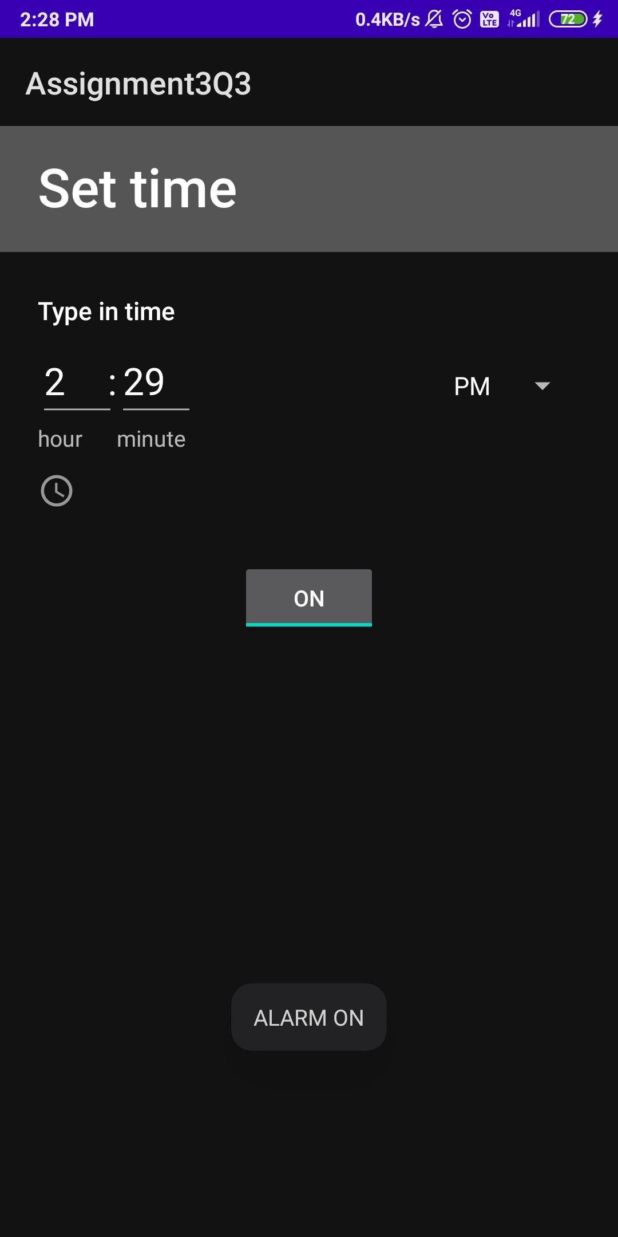

---------------------------------------------------------------------------------------------------------------------------

Q4. Create first activity to accept information like Student First Name, Middle Name,

Last Name, Date of birth, Address, Email ID and display all information on Second Activity when user click on Submit button.

MainActivity.java

package com.example.assignment3q4;  
  
import androidx.appcompat.app.AppCompatActivity;  
import android.content.Intent;  
import android.os.Bundle;  
import android.view.View;  
import android.widget.Button;  
import android.widget.EditText;  
import android.widget.TextView;  
  
import android.os.Bundle;  
  
public class MainActivity extends AppCompatActivity {  
  
 public static final String *EXTRA_FNAME* = "com.example.ass3Q4.EXTRA_FNAME";  
 public static final String *EXTRA_MNAME* = "com.example.ass3Q4.EXTRA_MNAME";  
 public static final String *EXTRA_LNAME* = "com.example.ass3Q4.EXTRA_LNAME";  
 public static final String *EXTRA_DOB* = "com.example.ass3Q4.EXTRA_DOB";  
 public static final String *EXTRA_ADDRESS* = "com.example.ass3Q4.EXTRA_ADDRESS";  
 public static final String *EXTRA_EMAIL* = "com.example.ass3Q4.EXTRA_EMAIL";  
  
 Button displayBtn;  
 EditText lname, dob, addr, email;  
  
 @Override  
 protected void onCreate(Bundle savedInstanceState) {  
 super.onCreate(savedInstanceState);  
 setContentView(R.layout.*activity_main*);  
  
 displayBtn = findViewById(R.id.*display*);  
  
 displayBtn.setOnClickListener(new View.OnClickListener() {  
 @Override  
 public void onClick(View v) {  
 displayOnActivity2();  
 }  
 });  
 }  
  
 public void displayOnActivity2(){  
  
 EditText fname = findViewById(R.id.*fname*);  
 String firstname = fname.getText().toString();  
  
 EditText mname = findViewById(R.id.*mname*);  
 String middleName = mname.getText().toString();  
  
 EditText lname = findViewById(R.id.*lname*);  
 String lastName = lname.getText().toString();  
  
 EditText dob = findViewById(R.id.*dob*);  
 String DOB = dob.getText().toString();  
  
 EditText addr = findViewById(R.id.*addr*);  
 String address = addr.getText().toString();  
  
 EditText email = findViewById(R.id.*email*);  
 String emailId = email.getText().toString();  
  
 Intent intent = new Intent(this, Activity2.class);  
 intent.putExtra(*EXTRA_FNAME*, firstname);  
 intent.putExtra(*EXTRA_MNAME*, middleName);  
 intent.putExtra(*EXTRA_LNAME*, lastName);  
 intent.putExtra(*EXTRA_DOB*, DOB);  
 intent.putExtra(*EXTRA_ADDRESS*, address);  
 intent.putExtra(*EXTRA_EMAIL*, emailId);  
  
 startActivity(intent);  
 }  
}

activity_main.xml

<?xml version="1.0" encoding="utf-8"?>  
<androidx.constraintlayout.widget.ConstraintLayout xmlns:android="http://schemas.android.com/apk/res/android"  
 xmlns:app="http://schemas.android.com/apk/res-auto"  
 xmlns:tools="http://schemas.android.com/tools"  
 android:layout_width="match_parent"  
 android:layout_height="match_parent"  
 tools:context=".MainActivity">  
  
 <EditText  
 android:id="@+id/lname"  
 android:layout_width="367dp"  
 android:layout_height="46dp"  
 android:layout_marginBottom="36dp"  
 android:ems="10"  
 android:inputType="textPersonName"  
 android:text="Last name"  
 android:textColor="#000000"  
 app:layout_constraintBottom_toTopOf="@+id/dob"  
 app:layout_constraintEnd_toEndOf="parent"  
 app:layout_constraintStart_toStartOf="parent" />  
  
 <EditText  
 android:id="@+id/dob"  
 android:layout_width="367dp"  
 android:layout_height="46dp"  
 android:layout_marginBottom="40dp"  
 android:ems="10"  
 android:inputType="textPersonName"  
 android:text="Date of birth"  
 android:textColor="#000000"  
 app:layout_constraintBottom_toTopOf="@+id/addr"  
 app:layout_constraintEnd_toEndOf="parent"  
 app:layout_constraintStart_toStartOf="parent" />  
  
 <EditText  
 android:id="@+id/addr"  
 android:layout_width="367dp"  
 android:layout_height="46dp"  
 android:layout_marginBottom="36dp"  
 android:ems="10"  
 android:inputType="textPersonName"  
 android:text="Address"  
 android:textColor="#000000"  
 app:layout_constraintBottom_toTopOf="@+id/email"  
 app:layout_constraintEnd_toEndOf="parent"  
 app:layout_constraintStart_toStartOf="parent" />  
  
 <EditText  
 android:id="@+id/email"  
 android:layout_width="367dp"  
 android:layout_height="46dp"  
 android:layout_marginBottom="52dp"  
 android:ems="10"  
 android:inputType="textPersonName"  
 android:text=" Email ID"  
 android:textColor="#000000"  
 app:layout_constraintBottom_toTopOf="@+id/display"  
 app:layout_constraintEnd_toEndOf="parent"  
 app:layout_constraintStart_toStartOf="parent" />  
  
 <Button  
 android:id="@+id/display"  
 android:layout_width="wrap_content"  
 android:layout_height="wrap_content"  
 android:layout_marginBottom="96dp"  
 android:text="Display "  
 app:layout_constraintBottom_toBottomOf="parent"  
 app:layout_constraintEnd_toEndOf="parent"  
 app:layout_constraintStart_toStartOf="parent" />  
  
 <EditText  
 android:id="@+id/fname"  
 android:layout_width="367dp"  
 android:layout_height="46dp"  
 android:ems="10"  
 android:inputType="textPersonName"  
 android:text="First name"  
 android:textColor="#000000"  
 app:layout_constraintBottom_toTopOf="@+id/mname"  
 app:layout_constraintEnd_toEndOf="parent"  
 app:layout_constraintStart_toStartOf="parent"  
 app:layout_constraintTop_toTopOf="parent"  
 app:layout_constraintVertical_bias="0.693" />  
  
 <EditText  
 android:id="@+id/mname"  
 android:layout_width="367dp"  
 android:layout_height="46dp"  
 android:layout_marginBottom="36dp"  
 android:ems="10"  
 android:inputType="textPersonName"  
 android:text="Middle name"  
 android:textColor="#000000"  
 app:layout_constraintBottom_toTopOf="@+id/lname"  
 app:layout_constraintEnd_toEndOf="parent"  
 app:layout_constraintStart_toStartOf="parent" />  
</androidx.constraintlayout.widget.ConstraintLayout>

Activity2.java

package com.example.assignment3q4;  
  
import android.content.Intent;  
import android.os.Bundle;  
import android.widget.TextView;  
  
import androidx.appcompat.app.AppCompatActivity;  
  
public class Activity2 extends AppCompatActivity {  
  
 TextView tv1, tv2, tv3, tv4, tv5, tv6;  
  
 @Override  
 protected void onCreate(Bundle savedInstanceState) {  
 super.onCreate(savedInstanceState);  
 setContentView(R.layout.*activity_2*);  
  
 tv1 = findViewById(R.id.*textView*);  
 tv2 = findViewById(R.id.*textView2*);  
 tv3 = findViewById(R.id.*textView3*);  
 tv4 = findViewById(R.id.*textView4*);  
 tv5 = findViewById(R.id.*textView5*);  
 tv6 = findViewById(R.id.*textView6*);  
  
 Intent intent = getIntent();  
 String op1 = intent.getStringExtra(MainActivity.*EXTRA_FNAME*);  
 String op2 = intent.getStringExtra(MainActivity.*EXTRA_MNAME*);  
 String op3 = intent.getStringExtra(MainActivity.*EXTRA_LNAME*);  
 String op4 = intent.getStringExtra(MainActivity.*EXTRA_DOB*);  
 String op5 = intent.getStringExtra(MainActivity.*EXTRA_ADDRESS*);  
 String op6 = intent.getStringExtra(MainActivity.*EXTRA_EMAIL*);  
  
 tv1.setText("First Name: "+ op1);  
 tv2.setText("Middle Name: "+ op2);  
 tv3.setText("Last Name: "+ op3);  
 tv4.setText("DOB: "+ op4);  
 tv5.setText("Address: "+ op5);  
 tv6.setText("Email: "+ op6);  
 }  
}

activity_2.xml

<?xml version="1.0" encoding="utf-8"?>  
<androidx.constraintlayout.widget.ConstraintLayout xmlns:android="http://schemas.android.com/apk/res/android"  
 xmlns:app="http://schemas.android.com/apk/res-auto"  
 xmlns:tools="http://schemas.android.com/tools"  
 android:layout_width="match_parent"  
 android:layout_height="match_parent"  
 tools:context=".Activity2">  
  
 <TextView  
 android:id="@+id/textView"  
 android:layout_width="335dp"  
 android:layout_height="44dp"  
 android:textSize="24sp"  
 android:textStyle="bold"  
 app:layout_constraintBottom_toTopOf="@+id/textView2"  
 app:layout_constraintEnd_toEndOf="parent"  
 app:layout_constraintHorizontal_bias="0.46"  
 app:layout_constraintStart_toStartOf="parent"  
 app:layout_constraintTop_toTopOf="parent"  
 app:layout_constraintVertical_bias="0.798" />  
  
 <TextView  
 android:id="@+id/textView2"  
 android:layout_width="340dp"  
 android:layout_height="41dp"  
 android:layout_marginBottom="532dp"  
 android:textSize="24sp"  
 android:textStyle="bold"  
 app:layout_constraintBottom_toBottomOf="parent"  
 app:layout_constraintEnd_toEndOf="parent"  
 app:layout_constraintHorizontal_bias="0.492"  
 app:layout_constraintStart_toStartOf="parent" />  
  
 <TextView  
 android:id="@+id/textView3"  
 android:layout_width="340dp"  
 android:layout_height="41dp"  
 android:layout_marginBottom="468dp"  
 android:textSize="24sp"  
 android:textStyle="bold"  
 app:layout_constraintBottom_toBottomOf="parent"  
 app:layout_constraintEnd_toEndOf="parent"  
 app:layout_constraintHorizontal_bias="0.492"  
 app:layout_constraintStart_toStartOf="parent" />  
  
 <TextView  
 android:id="@+id/textView4"  
 android:layout_width="340dp"  
 android:layout_height="41dp"  
 android:layout_marginBottom="408dp"  
 android:textSize="24sp"  
 android:textStyle="bold"  
 app:layout_constraintBottom_toBottomOf="parent"  
 app:layout_constraintEnd_toEndOf="parent"  
 app:layout_constraintHorizontal_bias="0.492"  
 app:layout_constraintStart_toStartOf="parent" />  
  
 <TextView  
 android:id="@+id/textView5"  
 android:layout_width="340dp"  
 android:layout_height="41dp"  
 android:layout_marginBottom="344dp"  
 android:textSize="24sp"  
 android:textStyle="bold"  
 app:layout_constraintBottom_toBottomOf="parent"  
 app:layout_constraintEnd_toEndOf="parent"  
 app:layout_constraintHorizontal_bias="0.535"  
 app:layout_constraintStart_toStartOf="parent" />  
  
 <TextView  
 android:id="@+id/textView6"  
 android:layout_width="340dp"  
 android:layout_height="41dp"  
 android:layout_marginBottom="276dp"  
 android:textSize="24sp"  
 android:textStyle="bold"  
 app:layout_constraintBottom_toBottomOf="parent"  
 app:layout_constraintEnd_toEndOf="parent"  
 app:layout_constraintHorizontal_bias="0.535"  
 app:layout_constraintStart_toStartOf="parent" />  
</androidx.constraintlayout.widget.ConstraintLayout>

AndroidManifest.xml

<?xml version="1.0" encoding="utf-8"?>  
<manifest xmlns:android="http://schemas.android.com/apk/res/android"  
 package="com.example.assignment3q4">  
  
 <application  
 android:allowBackup="true"  
 android:icon="@mipmap/ic_launcher"  
 android:label="@string/app_name"  
 android:roundIcon="@mipmap/ic_launcher_round"  
 android:supportsRtl="true"  
 android:theme="@style/Theme.Assignment3Q4">  
 <activity android:name=".Activity2"  
 android:parentActivityName=".MainActivity"></activity>  
 <activity android:name=".MainActivity">  
 <intent-filter>  
 <action android:name="android.intent.action.MAIN" />  
  
 <category android:name="android.intent.category.LAUNCHER" />  
 </intent-filter>  
 </activity>  
 </application>  
  
</manifest>

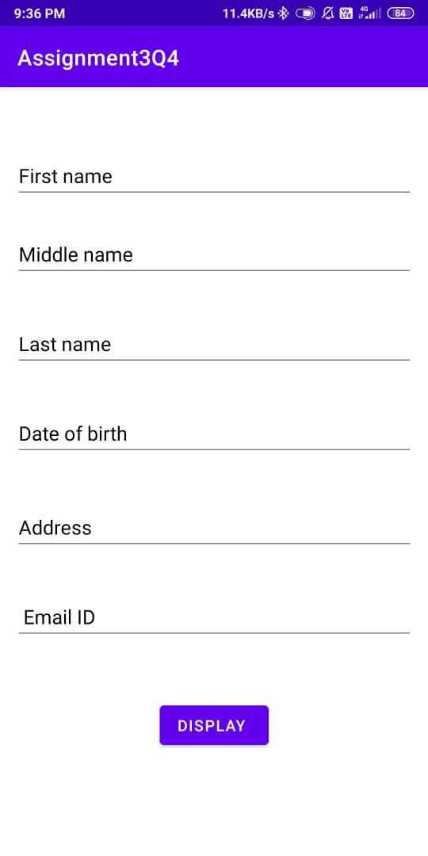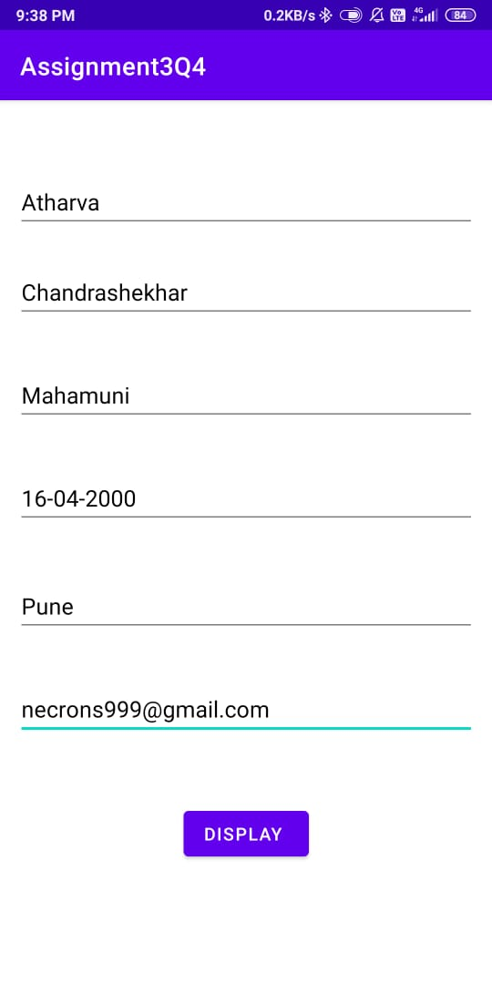

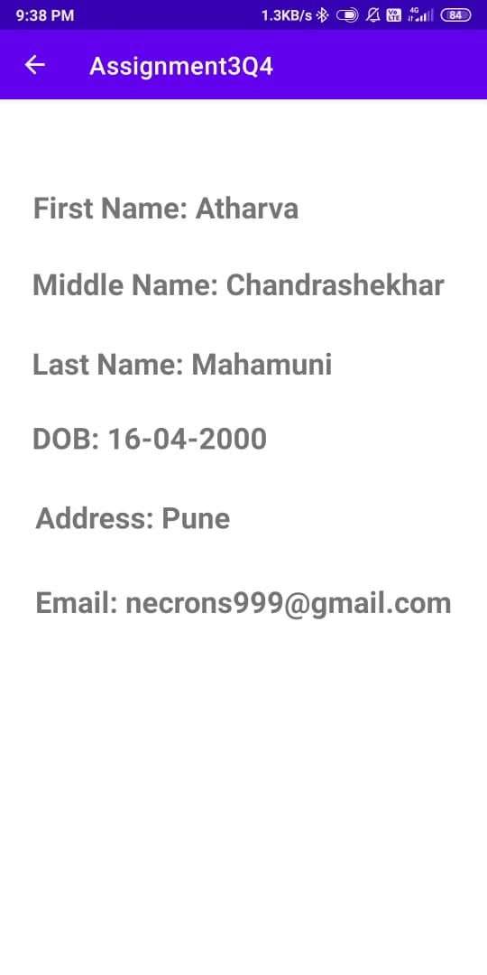

---------------------------------------------------------------------------------------------------------------------------

Q5. Create a java android application to raise a notification with title “Exam” & text “This

is exam notification”.

MainActivity.java

package com.example.assignment3q5;  
  
import android.app.Activity;  
import android.app.NotificationManager;  
import android.app.PendingIntent;  
import android.content.Context;  
import android.content.Intent;  
import android.os.Bundle;  
import android.view.View;  
import android.widget.Button;  
  
import androidx.core.app.NotificationCompat;  
  
public class MainActivity extends Activity {  
 Button b1;  
 @Override  
 protected void onCreate(Bundle savedInstanceState) {  
 super.onCreate(savedInstanceState);  
 setContentView(R.layout.*activity_main*);  
  
 b1 = (Button)findViewById(R.id.*button*);  
 b1.setOnClickListener(new View.OnClickListener() {  
 @Override  
 public void onClick(View v) {  
 addNotification();  
 }  
 });  
 }  
  
 private void addNotification() {  
 NotificationCompat.Builder builder =  
 new NotificationCompat.Builder(this)  
 .setSmallIcon(R.drawable.*abc*)  
 .setContentTitle("Notifications Example")  
 .setContentText("This is a test notification");  
  
 Intent notificationIntent = new Intent(this, MainActivity.class);  
 PendingIntent contentIntent = PendingIntent.*getActivity*(this, 0, notificationIntent,  
 PendingIntent.*FLAG_UPDATE_CURRENT*);  
 builder.setContentIntent(contentIntent);  
  
 // Add as notification  
 NotificationManager manager = (NotificationManager) getSystemService(Context.*NOTIFICATION_SERVICE*);  
 manager.notify(0, builder.build());  
 }  
}

activity_main.xml

<RelativeLayout xmlns:android="http://schemas.android.com/apk/res/android"  
 xmlns:tools="http://schemas.android.com/tools"  
 android:layout_width="match_parent"  
 android:layout_height="match_parent"  
 android:paddingBottom="@dimen/activity_vertical_margin"  
 android:paddingLeft="@dimen/activity_horizontal_margin"  
 android:paddingRight="@dimen/activity_horizontal_margin"  
 android:paddingTop="@dimen/activity_vertical_margin"  
 tools:context="MainActivity">  
  
 <TextView  
 android:id="@+id/textView1"  
 android:layout_width="wrap_content"  
 android:layout_height="wrap_content"  
 android:text="Notification Example"  
 android:layout_alignParentTop="true"  
 android:layout_centerHorizontal="true"  
 android:textSize="30dp" />  
  
 <TextView  
 android:id="@+id/textView2"  
 android:layout_width="wrap_content"  
 android:layout_height="wrap_content"  
 android:text="Tutorials point "  
 android:textColor="#ff87ff09"  
 android:textSize="30dp"  
 android:layout_below="@+id/textView1"  
 android:layout_centerHorizontal="true"  
 android:layout_marginTop="48dp" />  
  
 <ImageButton  
 android:layout_width="wrap_content"  
 android:layout_height="wrap_content"  
 android:id="@+id/imageButton"  
 android:src="@drawable/abc"  
 android:layout_below="@+id/textView2"  
 android:layout_centerHorizontal="true"  
 android:layout_marginTop="42dp" />  
  
 <Button  
 android:layout_width="wrap_content"  
 android:layout_height="wrap_content"  
 android:text="Notification"  
 android:id="@+id/button"  
 android:layout_marginTop="62dp"  
 android:layout_below="@+id/imageButton"  
 android:layout_centerHorizontal="true" />  
  
</RelativeLayout>

NotificationView.java

package com.example.assignment3q5;  
  
import android.os.Bundle;  
import android.app.Activity;  
  
public class NotificationView extends Activity{  
 @Override  
 public void onCreate(Bundle savedInstanceState){  
 super.onCreate(savedInstanceState);  
 setContentView(R.layout.*notification*);  
 }  
}

notofication.xml

<?xml version="1.0" encoding="utf-8"?>  
<LinearLayout xmlns:android="http://schemas.android.com/apk/res/android"  
 android:orientation="vertical"  
 android:layout_width="fill_parent"  
 android:layout_height="fill_parent" >  
  
 <TextView  
 android:layout_width="fill_parent"  
 android:layout_height="400dp"  
 android:text="This is exam notification" />  
</LinearLayout>